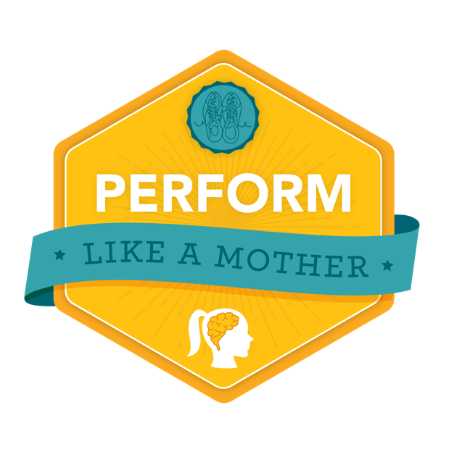
ATHLETE BACKGROUND

Hello! Please fill out the following information and return it to tlamclub@anothermotherrunner.com at least two days prior to your session. (You can fill it all out, or just what you’d like; totally up to you!) We will share with Justin Ross so he has an idea of your background. Thanks!

Background
Name:

Age:

Location:

Family Information:

Athletic History
How long have you been running?

Do you consider yourself an athlete? Why or why not?

In the past, what other sports have you played or competed?

What other sports/exercise do you engage in currently?

What upcoming races are on your calendar?

